# **Creating HDInsight Spark Cluster using PowerShell Script**

This demo is to create HDInsight Spark Cluster using PowerShell script. Follow the below given steps to deploy the cluster.

**Starting Cloud Shell:**

Login to azure portal and click on the cloud shell option that is available in the top. Click on **PowerShell (Windows)**. Choose a **Subscription** and click on **Create Storage**. This will open the cloud shell in azure.

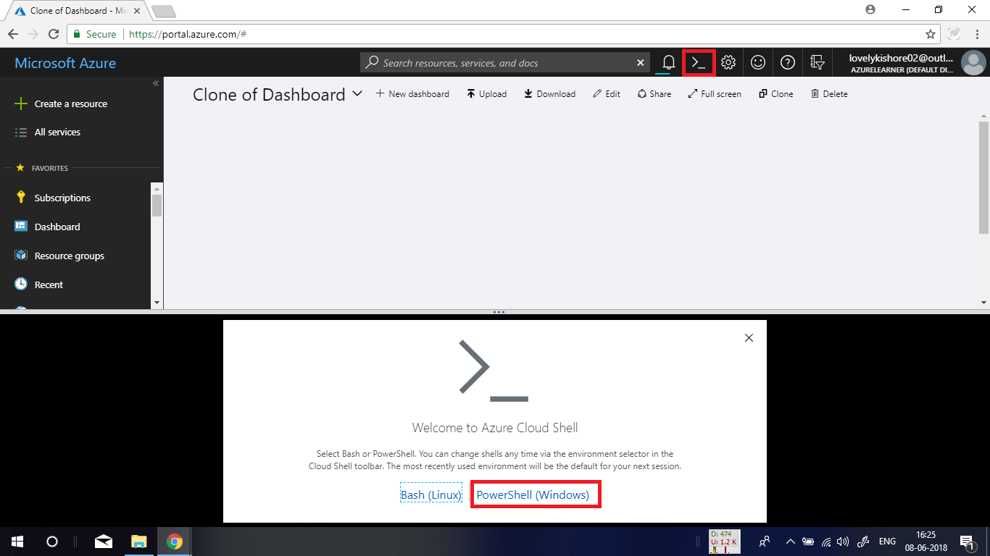

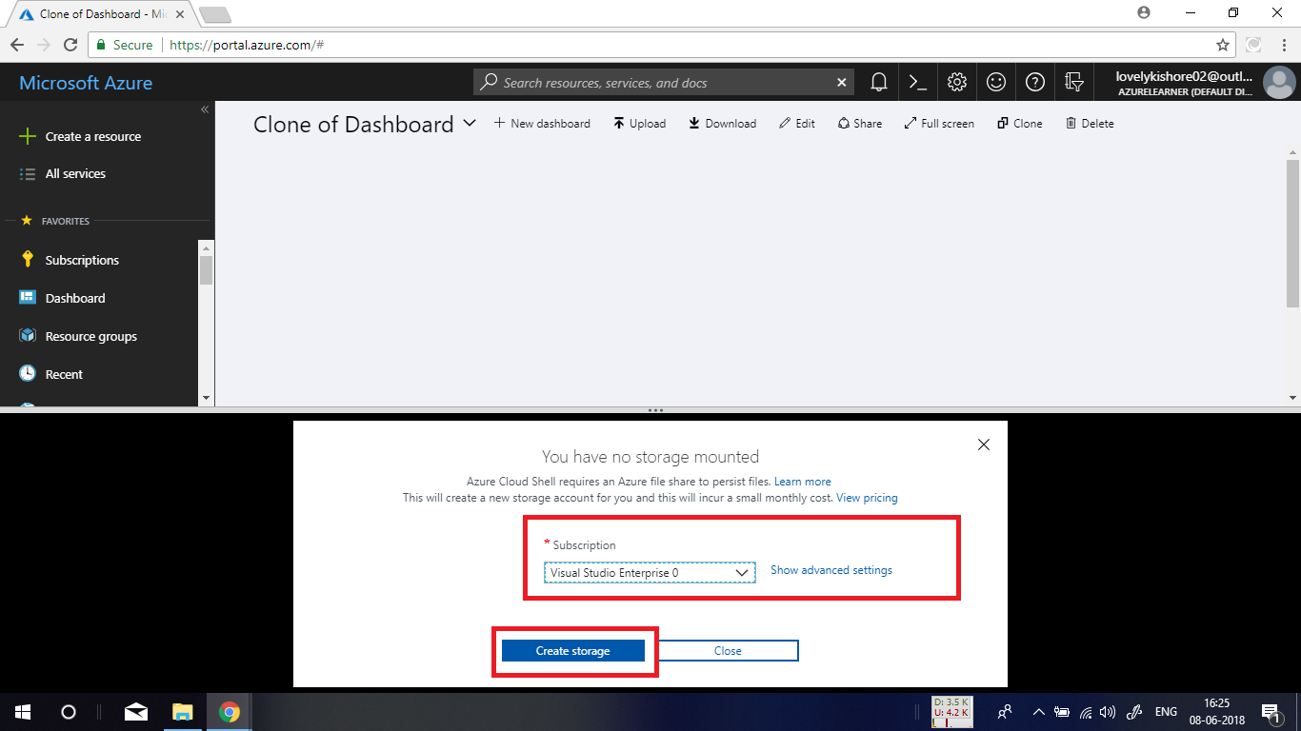

**Deploying HDInsight Spark Cluster:**

In the below given code, replace the user name with your desired name. It is denoted with the yellow mark. After changing the user name, copy and paste the script into PowerShell.

**PowerShell Script to Deploy Cluster:**

### Create a Spark 2.2 cluster in Azure HDInsight

# Create the resource group

$resourceGroupName = Read-Host -Prompt "Enter the resource group name"

$location = Read-Host -Prompt "Enter the Azure region to create resources in, such as 'Central US'"

New-AzureRmResourceGroup -Name $resourceGroupName -Location $location

$defaultStorageAccountName = Read-Host -Prompt "Enter the default storage account name"

# Create an Azure storae account and container

New-AzureRmStorageAccount `

-ResourceGroupName $resourceGroupName `

-Name $defaultStorageAccountName `

-Type Standard_LRS `

-Location $location

$defaultStorageAccountKey = (Get-AzureRmStorageAccountKey `

-ResourceGroupName $resourceGroupName `

-Name $defaultStorageAccountName)[0].Value

$defaultStorageContext = New-AzureStorageContext `

-StorageAccountName $defaultStorageAccountName `

-StorageAccountKey $defaultStorageAccountKey

# Create a Spark 2.2 cluster

$clusterName = Read-Host -Prompt "Enter the name of the HDInsight cluster"

# Cluster login is used to secure HTTPS services hosted on the cluster

$httpCredential = Get-Credential -Message "Enter Cluster login credentials" -UserName "kishore"

# SSH user is used to remotely connect to the cluster using SSH clients

$sshCredentials = Get-Credential -Message "Enter SSH user credentials"

# Default cluster size (# of worker nodes), version, type, and OS

$clusterSizeInNodes = "1"

$clusterVersion = "3.6"

$clusterType = "Spark"

$clusterOS = "Linux"

# Set the storage container name to the cluster name

$defaultBlobContainerName = $clusterName

# Create a blob container. This holds the default data store for the cluster.

New-AzureStorageContainer `

-Name $clusterName -Context $defaultStorageContext

$sparkConfig = New-Object "System.Collections.Generic.Dictionary``2[System.String,System.String]"

$sparkConfig.Add("spark", "2.2")

# Create the HDInsight cluster

New-AzureRmHDInsightCluster `

-ResourceGroupName $resourceGroupName `

-ClusterName $clusterName `

-Location $location `

-ClusterSizeInNodes $clusterSizeInNodes `

-ClusterType $clusterType `

-OSType $clusterOS `

-Version $clusterVersion `

-ComponentVersion $sparkConfig `

-HttpCredential $httpCredential `

-DefaultStorageAccountName "$defaultStorageAccountName.blob.core.windows.net" `

-DefaultStorageAccountKey $defaultStorageAccountKey `

-DefaultStorageContainer $clusterName `

-SshCredential $sshCredentials

Get-AzureRmHDInsightCluster -ResourceGroupName $resourceGroupName -ClusterName $clusterName

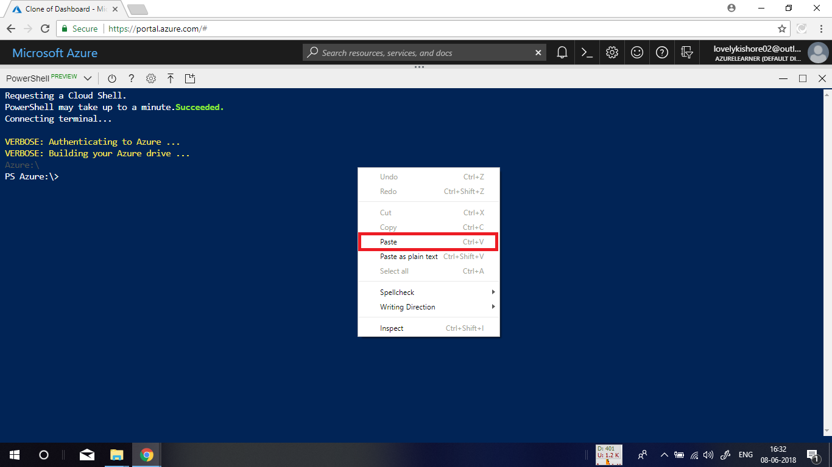

Give a name for your **resource group**, enter a **location** for the resource group and give a name for your storage account that you want to create for your HDInsight Spark cluster.

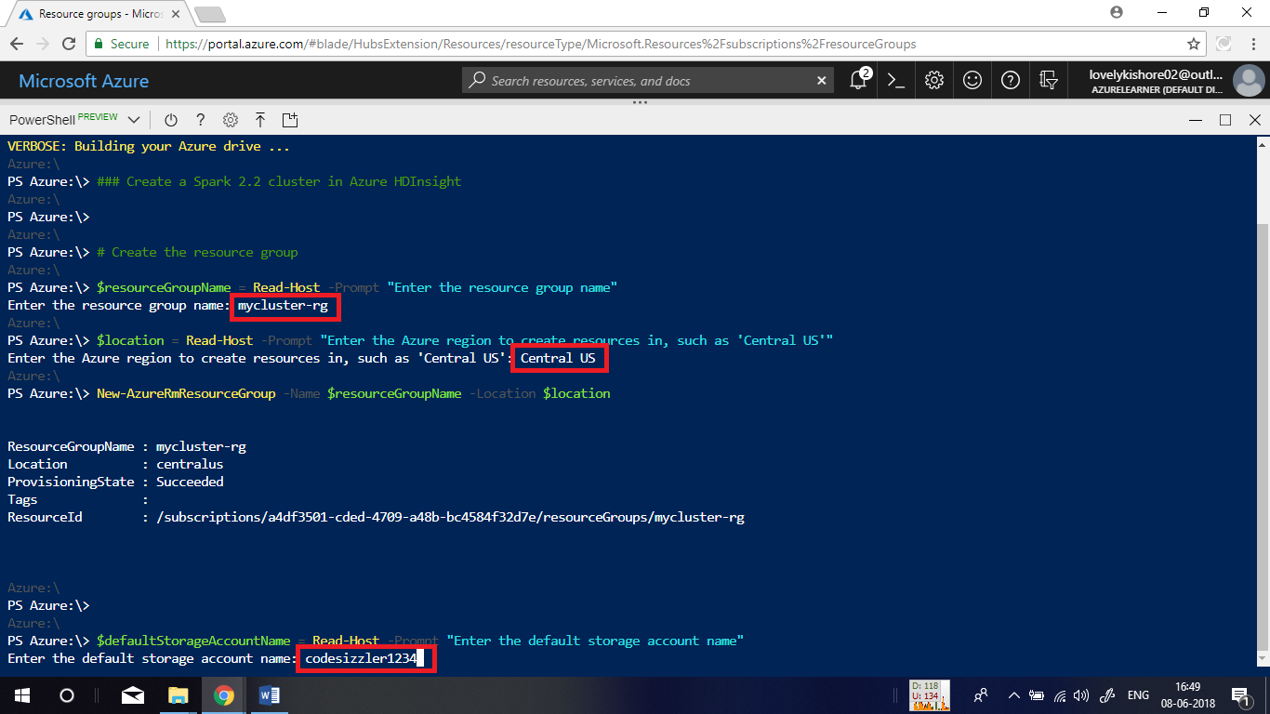

Dynamically, you will also be asked to give a name for your cluster. Give a name for it. You have given an username for logging into the cluster in the script itself. Now you will be asked to enter password. Give a password. Again, for SSH login, give an username and password and hit enter.

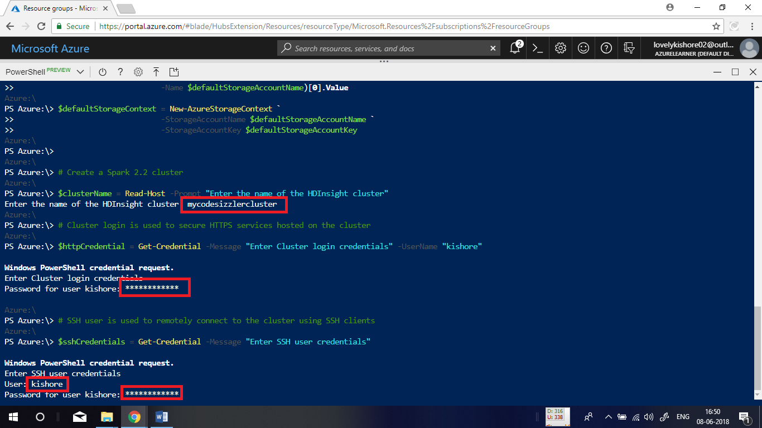

The deployment of resource will take up to twenty minutes. After twenty minutes, you will be displayed with the following output station that the cluster has been deployed.

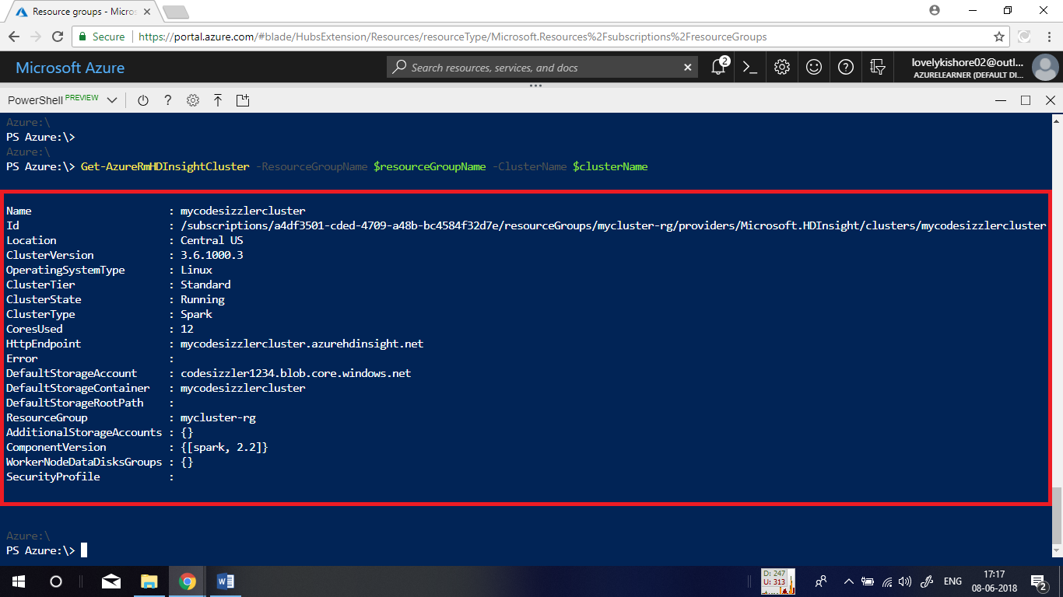

Check the deployed cluster in portal now.